41.14: a) According to Fig. 41.8 there are three different transitions that are consistent with the selection rules. The initial 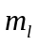 values are 0, 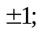 and the final value is 0.
b) The transition from 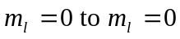 produces the same wavelength (122 nm) that was seen without the magnetic field.
c) The larger wavelength (smaller energy) is produced from the 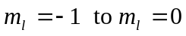 transition.
d) The shorter wavelength (greater energy) is produced from the 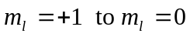 transition.

